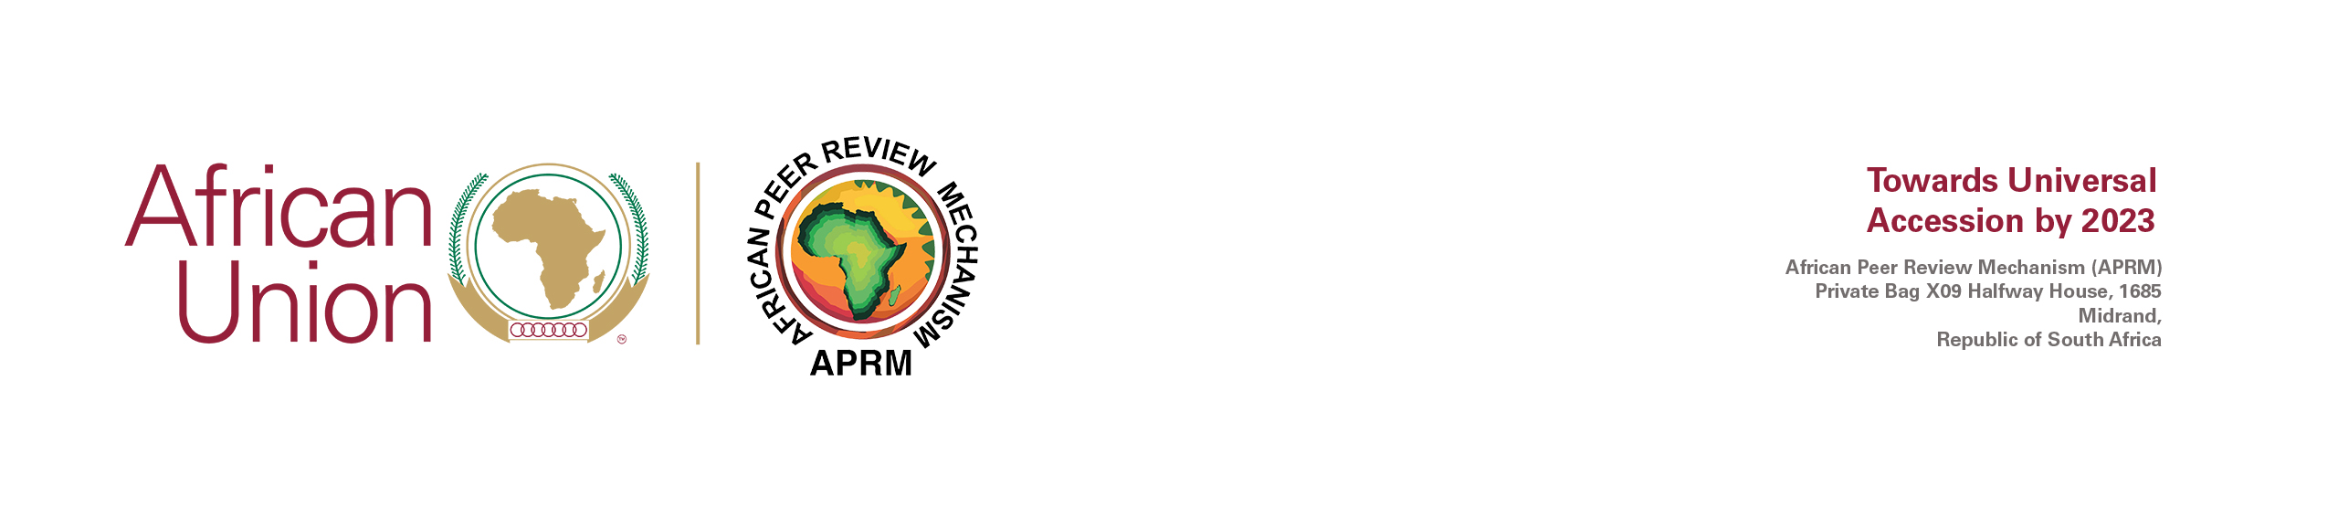
FOR IMMEDIATE RELEASE

APRM STATEMENT ON THE RATING DOWNGRADE OF GHANA BY S&P AND FITCH RATINGS

12 August 2022 The African Peer Review Mechanism (APRM), which has the mandate from the African Union Assembly to support African countries in the area of credit ratings, undertakes routine analyses of rating actions assigned by international credit ratings agencies on African countries.

The APRM has noted with concern the increase in the number of negative rating actions against African countries by the three international rating agencies. The downgrade of Ghana is the latest such rating actions in which the country’s long-term foreign currency sovereign rating was lowered further into junk grade, from B- to CCC+ with negative outlook and B- to CCC by S&P and Fitch on 5th and 10th August 2022, respectively. This is the third and fourth consecutive rating downgrades on Ghana by the three major international rating agencies since the beginning of 2022.

The APRM corroborates with the Government of Ghana in expressing its reservations on the decisions by the international rating agencies to downgrade Ghana despite the credit-positive policies being implemented to address various macro-fiscal challenges that the country is facing. Whilst the effects of the COVID-19 pandemic and the severe global shock of the crisis in Ukraine on Ghana, highlighted by S&P and Fitch can be acknowledged, the speculative comments and ratings actions by the international rating agencies in the first half of 2022 materially contributed to the country’s losing access to international financial markets.

The APRM views the unjustified negative rating actions in Africa since the beginning of 2022 as unwarranted and contrasting the continent’s economic recovery efforts from the devastating impact of the Covid-19 pandemic. This is compounding the complexity of driving the economic recovery process and making current fiscal measures ineffective.

In view of the continuing trend of negative credit rating actions on the continent, the APRM calls for coordinated response to address the ongoing speculative pessimism by analysts and for ratings to be enablers rather than impediments of economic recovery. The response mechanisms include regulatory measures, developing alternative ratings and alternative fundings sources. END

APRM Media & Communication
For inquiries please contact: Liziwe Masilela (Head of Communications APRM) on Liziwe.masilela@aprm-au.org

