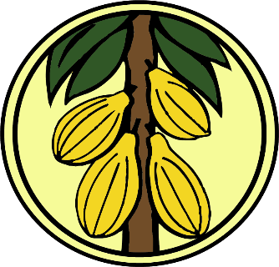
PRESS
RELEASE
GHANA COCOA BOARD Date: 25TH MAY 2022

ALL MEDIA HOUSES

CLOSURE OF THE 2021/2022 MAIN CROP COCOA SEASON
It is hereby notified for general information that purchases of the 2021/2022 Main Crop Cocoa Season will close on THURSDAY, 26TH MAY 2022.
In order to assist the Licensed Buying Companies (LBCs) to obtain the final returns from up-country, Ghana Cocoa Board has decided that returns on the declared purchases will be accepted up to 4:00 p.m. on THURSDAY, 2nd JUNE 2022.

ISSUED BY:
CHIEF EXECUTIVE

For more information, please contact the Public Affairs Department, Ghana Cocoa Board Office Direct Line: (0302) 66-17-66
E-mail: public_affairs@cocobod.gh

ISSUED BY:
…………###

